Pax Christi Massachusetts Newsletter

Violence Ends Where Love Begins Volume 29, Number 1, Summer-Fall 2022

Pax Christi 2022 Teacher of Peace
By Marie Dennis

[Former co-president of Pax Christi International and program chair for the Catholic Nonviolence Initiative Marie Dennis delivered these remarks on receiving Pax Christi USA’s Teacher of Peace award at their national conference in Washington, DC, on August 7, 2022; they are reprinted here by permission of the author. -Ed.]

Thank you so much, Bishop [John] Stowe – and Joe [Fr. Joseph Nangle, OFM]. I am humbled, more than a little uncomfortable and deeply grateful for this honor. I have such tremendous respect for Pax Christi – for all that you stand for and for your deep commitment to promoting peace rooted in justice, to dismantling racism and the other expressions of virulent violence, and to becoming the beloved community.

Ilia Delio challenges us to “co-create a world bounded in love.” You are doing exactly that!
Fifty years ago, Pax Christi USA was founded in an era enriched by:
**a series of brilliant, strategic, decidedly nonviolent campaigns toward racial justice that together shaped the civil rights movement;
**the black power movement in this country and around the world;
**the Second Vatican Council that at least began to open a few of the locked windows of the Catholic Church;
**the grape and lettuce boycotts organized by Cesar Chavez, Dolores Huerta and the UFWA;
**a powerful contextual theological genre, liberation theology, that was articulated by oppressed, marginalized and impoverished communities;
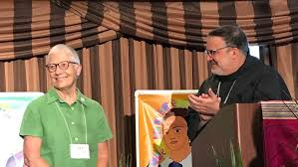
Receiving the Teacher of Peace award from Bishop Stowe (paxchristiusa.org)
**struggles for independence across Africa; for liberation across Latin America;
**an active and short-lived global response to the global food crisis, the oil crisis, the cry of the earth;
**a movement committed to solidarity and accompaniment in the context of US proxy wars and dirty wars across the Americas
**a peace movement that finally ended the Vietnam War; that struggled mightily for nuclear disarmament, for demilitarization of US foreign policy, for an end to enemy-making, for an end to the Cold War...I could go on.
Continued on page 4
Co-Coordinator’s: Column: 50 Years of Pax Christi USA
By Fr. Rocco Puopolo
“Seeing through the Prism of Justice” was the theme of the 50th Anniversary Pax Christi Assembly held in Washington, DC in August. Six of us from Massachusetts were present in person, and many others zoomed in virtually…a total of 325 peacemakers in person and another 100 or so virtually…an appropriate theme, as we were indeed a prism of faith and advocacy for peace, a diverse, intergenerational crowd who came to mark this moment.
For me our gathering started on Thursday, August 4^{th,} with a preconference meeting of the regional state leaders, representing some 27 states. After introducing one another and highlighting some of our activities, we looked at three issues that called for our attention: the need for anti-racism training on a local level, the challenge to engage and invite youth to Pax Christi; and creative ways to
Continued on page 2
NOTE: To promote a greener future with a leaner budget, print copies of this newsletter are mailed only to our readers who have no access to email.

Co-Coordinator’s
Column…
Continued from page 1

engage and invite youth to Pax Christi and creative ways to ground Pax Christi in parishes through the country. Ample time was given for input, follow-up discussion, and sharing. No one had the “magic wand” that could solve any of these challenges, but suggestions were proposed, and support was offered in our attempts to meet these challenges. We are a work in progress.
There was a concurrent meeting that gathered the Pax Christi Youth Caucus, some 20 young people who are developing Pax Christi among their peers. We from Massachusetts were represented by one such youth, Clem Kimani, a sophomore from the College of Our Lady of the Elms in Chicopee.
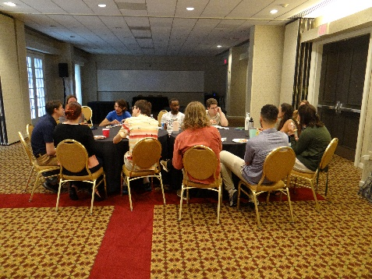
Youth Caucus meeting, with Clem at center rear (paxchristiusa.org)
The main assembly began Friday night with a keynote address by Archbishop John Wester of Santa Fe, New Mexico. He offered his thoughts, not only drawn from his recent pastoral letter “Living in the Light of Christ’s Peace: A Conversation toward Nuclear Disarmament,” but further reflections and developments since its publication. He was very grateful to Pax Christi USA for publishing the hard copy of this letter as well as the many local groups that are seriously engaging local Church with his message.
On the local scene in New Mexico, he is initiating a number of conversations with those involved in the nuclear enterprise there, both scientists and administrators, to move many of the issues he mentions in the letter to reality. His words were overwhelmingly welcomed by the assembly. He remained with us throughout the weekend, and his presence was greatly appreciated.
On Saturday there were two workshop sessions that offered participants a wide variety of learning on topics that Pax Christi is concerned about, from racism, immigration, and nuclear issues, to contemplative foundations needed for peacemaking and youth engagement. The day concluded with the Anniversary Banquet, where Pax Christi turned up the volume to celebrate who we were, are and will be in a celebratory fashion, accompanied by fine music from Mali! Some danced the night away! Throughout the dinner, many were recognized for being part of what Pax Christi has become through the years. It was a very affirming celebration.
Sunday began with a powerful sharing by Marie Dennis, the 2022 Teacher of the Peace, which is featured in this newsletter. It is a great read. It filled us all with hope in spite of the overwhelming challenges to peace that are part of our world today. Something new is afoot, and we can be part of that! She helps us see it.
The Assembly ended with a final Mass, celebrated by Bishop John Stowe, OFM, our Pax Christi USA Bishop President, accompanied by Archbishop Wester. His homily, found on the Pax Christi USA website, was also challenging, affirming, and hope-filled. At the conclusion of that Mass, the 20 new Ambassadors of Peace were commissioned, including Sr. Jane Morrissey, SSJ, of Springfield.
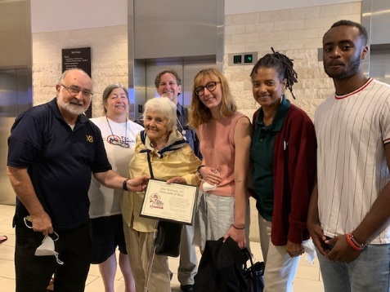
Fr. Rocco, Sr. Jane, and friends from Massachusetts and beyond (photo by Annette McDermott)
It was clear that we are a lively movement, committed to nonviolence and peacemaking, looking forward in faith and joy to a future filled with hope where we can make a difference, repair broken relationships, and change the “culture of death and exclusion” to one of restored relationships and peace. As a proverb from Sierra Leone states: “when spiders gather, even a lion can be contained.”
Fr. Rocco Puopolo, s.x., is co-coordinator, with Pat Ferrone, of Pax Christi Massachusetts.

Grants from PCMA
to Local PC Groups
Local groups may apply for grants of up to $250 to support projects which are in keeping with Pax Christi’s mission by requesting an application form from: Pax Christi Massachusetts, Good Shepherd Parish, 99 Main Street, Wayland, MA 01778; or via email at: paxchristima@gmail.com
Teacher of Peace…
Continued from page 1
I am still asking what is the role of a white, middle class Catholic woman from the belly of the beast in response to these cries for justice and liberation. I knew 50 years ago and still believe that somehow I had to address root causes because I am responsible for so many of them; and that my lifestyle and location/where I spent my time had to be informed by the wisdom and experience of the people on whose backs I was standing every day -- people at the peripheries, survivors of racism, oppression, economic violence.

50 years later, the struggle seems the same, yet it is radically different. And that difference fills me with hope – not thin hope, but rich, vibrant, thick hope. I believe that we are on the threshold of a new way of being, a new paradigm, a new logic for life. What we are birthing will be closer to the beloved community; it will be anti-racist and socially just. It will be built on right relationships with each other and with the natural world. It will be richly, beautifully diverse and decidedly nonviolent. It will not depend on weapons of war but on right relationships, a commitment to inclusive human dignity, and respect for the integrity of creation.

This new paradigm will be based on a completely different understanding of our place as humans in the whole Earth community -- and a recognition that we are latecomers at that to a spectacular cosmic reality that we are just now (thanks to the Hubble and Webb telescopes) beginning to see. It will recognize that diversity and relationality are imbedded in the cosmos and essential to survival on this planet. And it will clearly identify and reject violence in all its forms: armed violence, physical violence, structural and systemic violence, gender and racial violence, cultural, ecological, economic, spiritual, and psychological violence.
Ilia Delio talks about “the new person” emerging in evolution, who is embracing pluralities of gender, race and religion; who is called into a “new type of consciousness where things are first seen together and then as distinct within this togetherness.” She affirms that we are being rewired for belonging to the cosmic whole. We are more and more aware that we are one earth community; we have a planetary consciousness that, according to Ilia, evokes a deep concern, especially in younger generations, for the planet and for those who are impoverished or marginalized.
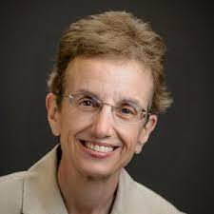
Ilia Delio (christogenesis.org)
She calls younger generations – many of you – “digital natives” because they (you) were “born into a networked world and ... think across lines of relationships.” In fact, Ilia says, “we are beginning to see that systems in nature do not work on principles of competition and struggle but on cooperation and sympathy.”

Michael Nagler, founder of the Metta Center for Nonviolence, talks about the “new story” that is replacing the “old story” told by the dominant white culture about scarcity, competition and violence. He insists that violence is not the nature of humans - that love, faith, trust and the desire for community, peace and well-being are central to our identity and that nonviolence is a creative power, a pervasive energy, a fundamental principle that we can develop and deploy in human interactions. “Violence,” he says, “is a tendency that pulls us back, away from the recognition of unity; nonviolence pulls us forward, toward that recognition ... We human beings ... can play an active role in our own evolution and consequently that of our species. The discovery of our capacity for nonviolence, connected as it is with higher consciousness or love, is a key to this development ...Nonviolence is not only at home in the new story, it is the new story.”
That is the nature of the nonviolence that Pax Christi is learning to embrace. It is more than pacifism; it is a spirituality, a way of life - let me say that again, though you know it very well – it is a spirituality and a way of life, a new way of thinking. It is a potentially universal ethic that could guide the world, including in times of crisis, toward just peace rather than justified war, toward respect and inclusion rather than exploitation. And it is a proven, effective approach to deep peace seen through the prism of justice.
Pax Christi’s commitment is to a nonviolence that imitates Jesus’ way of life but that is also challenged and shaped by the history and contemporary experience of those on the receiving end of war and racism and neglect and planetary destruction. As I said in the panel yesterday, it is not just not violent but is muscular and actively engaged in preventing or interrupting the violence that is imbedded in our culture, by the way we relate to each other, by the way too many in our society have been and still are bruised, broken, killed by “the system” and by the way we humans treat the earth. And it is a nonviolence that energetically promotes just peace, the new story, the beloved community, the New Creation.

I see this shift happening everywhere. I know thousands and thousands of people, whole communities around the world who are giving their lives to making the new story real – beginning with my own children, their children, their colleagues, all of you and the many circles of struggle with which you/we connect. I see it in brilliant work to root out systemic racism, voter suppression and structural injustice, to end the death penalty and mass incarceration, to redress centuries of oppression against indigenous communities, to break habits of exploitation that are destroying the earth, to learn and promote restorative justice practices, to welcome migrants and refugees, to rid the world of nuclear weapons, to fundamentally rework US budget priorities, to celebrate diversity and promote unwavering inclusion and respect for the rights of all people no matter how they identify, believing that radical inclusion is the foundational message of the Sermon on the Mount.

I see it in efforts (including my own) to be respectful and deeply inclusive in our use of language, including pronouns (I use “she, her, hers”); in growing awareness of where our feet are planted. In this place, in Arlington Virginia, we acknowledge with gratitude and deep respect to elders both past and present that we are gathered on the traditional land of the Anacostans, the Piscataway and the Pamunkey people.
I see the new story in Pax Christi’s deep engagement with so many of these intersecting violences and in our searching, evolving contextual commitment to Gospel nonviolence. I see it in the courage and willingness on the part of PCUSA members of color and the many Pax Christi colleagues around the world who have been brutally harmed by our country’s policies and way of life, but who stay in/so often lead the struggle for justice and liberation knowing that liberation, much more than individual liberty, is an essential contribution to the common good.
I see a paradigm shift led by Pope Francis’ vision, creativity and commitment to the cry of the earth and the cry of those forced to live on the margins of our world. I see a leaning toward nonviolence in
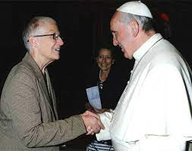
Marie Dennis and Pope Francis
(rosemarieberger.com)
Catholic social thought that is being enhanced by the synodal
process; and I see a complex and troubled institutional Church that here and there, including in the Vatican, has been amazingly open to engaging with our Catholic Nonviolence Initiative.

Five years ago, in his 2017 World Day of Peace message, Pope Francis said, “to be true followers of Jesus today also includes embracing His teaching about nonviolence. …I pledge the assistance of the Church in every effort to build peace through active and creative nonviolence.”
We are doing all that we can to take Pope Francis up on his offer, urging the Church to promote the necessary shift from an ethic of violence and war to an ethic of nonviolence -- through Catholic universities, religious communities, diocesan and parish programs, Catholic communications and diplomatic efforts. To reclaim the centrality of Gospel nonviolence would require a radical transformation of the internal life of the Catholic Church, as well as the public face, voice and engagement of the institution.

But the pushback to this proudly radical movement, of which you are such an important part, is ferocious and powerful; our work is not done, and I am afraid it won’t be for a long time. This is a truly generational effort – so a big thank you to the younger members of Pax Christi USA who are so ably assuming leadership in our movement!
Let me just say a few words about the war in Ukraine and about the culture wars in our own society, which, though profoundly different, are important examples of this aggressive opposition to the new story, the paradigm shift for which we are yearning.

We have all watched in horror as the Russian invasion of Ukraine escalated into a war of immense brutality with vicious attacks on civilians and essential infrastructure; a blockade that dramatically increased food insecurity, especially in the Middle East and Africa; and an ominous threat to use nuclear weapons.
The war in Ukraine is not more important than the other violences destroying human lives and the earth, but it is extremely serious because it is threatening to upend humanity’s real, though still very tentative, steps toward a new way of being on planet earth.

The Ukraine war has greatly intensified the choice between life and death. Either we will continue to live our way into the new story of right relationships and commit to developing and scaling up diverse, powerful nonviolent tools to address root causes of conflict before it reaches such catastrophic proportions, or we will remain stuck in the old story that violence and war are inevitable.
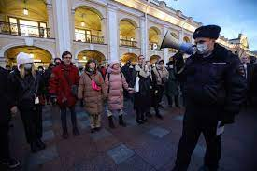
Russians in St. Petersburg protest the war in Ukraine (paceebene.org)
Even now, although examples of creative, active nonviolence on the ground in Ukraine and Russia are plentiful, and nonviolence practitioners in Ukraine, Eastern Europe and around the world have proposed a strategy of essential nonviolent actions for during and after the war, weapons continue to flow to Ukraine and nonviolent strategies are largely marginalized.

For as long as we humans fail to absorb the significance of the new person emerging from evolution who is wired for cooperation and inclusion or to focus on making the shift to nonviolence that I have been describing, military action will always appear to be the only option, creating a platform for self-serving, powerful forces to fuel a new arms race; to re-center the insane and morally bankrupt strategy of nuclear deterrence; to dismiss the horrific loss of human life, damage to essential infrastructure and wounding of the precious earth community wherever wars are fought. The realization of a new paradigm based on nonviolence is even more necessary than it was a few months ago – and more difficult.
The other example – of culture wars in the United States - may be, if you can believe it, a slightly more hopeful sign. I say that because I believe that white nationalism, blatant racism, xenophobia, extreme individualism, irrational demands for personal liberty and individual security that undercut human security and the common good are a fear-driven reaction to the deep, transformative change that is underway, especially at a structural and systemic level.
We know now, and with so many others are now acting on the knowledge, that racism is imbedded in our culture and in our socio-economic structures; that enemy-making is good business for some; that nonviolent strategies have been proven to be effective; and that it is critically important that our society listens to and learns neglected or repudiated Black, Brown, Asian, indigenous, immigrant and LGBTQ histories and all of herstories. We are helping to realize a societal transformation that is slow but deep, powerful, threatening. And the stronger it is, the more effective, the more savage will be the backlash!

And so we will continue in the struggle, claiming the grace and courage to walk unafraid and filled with hope as new humans into the new story about nonviolence told to us by Jesus in his Sermon on the Mount.
Once again, what we are birthing will be closer to the beloved community; it will be anti-racist, diverse and socially just. It will be built on right relationships with each other and with the natural world. It will not depend on weapons of war but on a commitment to inclusive human dignity and respect for the integrity of creation. It will be diverse, nonviolent, a new way of being viewed through the prism of justice.
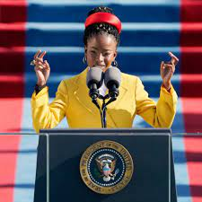
Inaugural poet Amanda Gorman
(blackcatholicmessenger.com)
With Amanda Gorman let us “raise this wounded world into a wondrous one...There is always light, if only we're brave enough to see it. If only we're brave enough to be it."

Thank you so much to Bishop Stowe, to Charlene [Howard] and the Pax Christi USA National Council; to Johnny [Zokovich] and to every member of the Pax Christi USA staff and the conference committees for this beautiful conference and for this honor.
-Marie Dennis is Pax Christi USA’s 2022 Teacher of Peace.
Video recordings, texts of speeches, photos, and other resources from the PCUSA 50th anniversary conference are available at this link: https://paxchristiusa.org/2022/08/23/save-the-date-pax-christi-usa-celebrates-50-years-at-the-national-conference/
Another View from PCUSA at 50 in DC
By Jeanne Allen
Beginning with a rousing time of music, prayer and blessing, 325 peacemakers, from infants to those in their 90’s, braved the DC heat and humidity to celebrate Pax Christi USA’s 50th Anniversary. Another 100 or so joined online. We were welcomed by National Council Chair Charlene Howard and Council member Manuel Padilla. Bishop Michael Burbridge (Arlington) and Cardinal Gregory (Washington) also sent a welcome, and there were video welcomes from Bishop Thomas Gumbleton, Sister Mary Lou Knowicki, Father Bryan Massingale, Sister Helen Prejean and Martin Sheen. Five attendees who have been members for the entire 50 years of PCUSA were recognized.
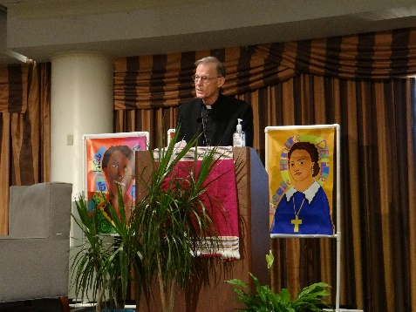
Keynote speaker Archbishop John Wester of Santa Fe, NM, reflected on Pope Francis’s call for nuclear disarmament and gospel nonviolence. He exhorted us each to practice, teach and spread the nonviolence of Jesus, reminding us that when James and John asked Jesus if they should call down fire on those who were not standing with Jesus, he rebuked them. The way of Jesus is to call down not hellfire, but blessings.
Archbishop Wester reflected on the “third way,” which stands between “fight” and “flight” in the face of threat. This is the way of “light and love,” which stands resolutely in the face of violence, reflects back the evil that is being done, and seeks a change of heart. Abolition of nuclear weapons is anti-racist, anti-poverty and pro-environment. He drew on Pope Francis, Dorothy Day, Martin Luther King, Jr. and Archbishop Desmond Tutu for varied examples of nonviolence. He also praised ICAN’s work to promote the UN Treaty on the Prohibition of Nuclear Weapons, reminding us that grassroots organization and mobilization are needed to address society’s apathy. He gave some rebuttals to the “but abolition is not practical, we need the jobs, etc.” arguments. He urged us to let out “imaginations go wild for peace,” be open to the Spirit’s prodding, and to remember that while we raise the issues/share the vision, the results are in God’s hands.
After his speech, Archbishop Wester had a conversation with Monsignor Ray East. “We need to disarm our own heart before we can disarm other countries,” said East. We need to continually “connect the dots” for people—“pro-life” and peace movement, the Gospel and our politics. East also drew our attention to the fact that Catholicism is the predominant religion claimed on Capitol Hill, as well as the Supreme Court and the President, so the time to bring the peace of Christ is right here and right now.
Saturday opened with a prayer service drawing on English, Spanish, Indigenous, African American, Japanese, Jewish and Arabic traditions in prayers, instrumental music and song. “Pax Christi USA 50th Anniversary Day” was proclaimed by Montgomery County, MD. The plenary was an intergenerational panel discussing an intersectional approach that makes the linkages between peacemaking, racism, consumerism, ecological justice and LGBTQ+ inclusivity explicit. Moderated by PCUSA Program Director Roxana Bendezú, it included panelists Cath Crayton (former National Council member and PC anti-racism team founding member), Marie Dennis [see page 1 – Ed.], Lauren Bailey (PCUSA Local Groups Liaison), Christina Leaño (Associate Director of the Laudato Si´ Movement), Megan McKenna (storyteller and cross-cultural social justice worker) and Shannen Dee Williams (University of Dayton historian and author of Subversive Habits: Black Catholic Nuns in the Long African American Freedom Struggle).
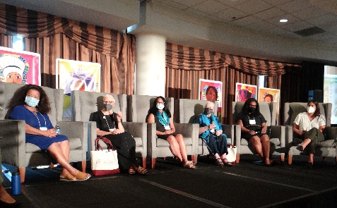
From a historical perspective (the 500th anniversary of Columbus’s coming to the Americas became the seed for Pax Christi to address racism), a reminder that violence is not just direct violence, it is also structural, to reflection on Father Massingale’s assertion at last year’s assembly that “the rise of white nationalism is the greatest threat to peace and justice in the US and the world,” the discussion was lively and insightful, always making connections. While the panelists did not agree on every statement, the consensus was “we’re evolving, we’re growing, and we are going to get it right.”

We then broke into workshops on a variety of topics. Each breakout session had a “holy person” as a guiding spirit, from Black Elk and Pierre Toussaint to Rutilio Grande, SJ, and Sister Dorothy Strang; from Thomas Merton and Archbishop Hunthausen to Sister Thea Bowman and Mother Mary Lange. Their icons rejoined us at the plenary sessions. Peace cranes decorated the ballroom where plenary sessions were held. More workshops took place after lunch.

Sunday brought the presentation of the 2022 Teacher of Peace Award to Marie Dennis, described as “brilliant, passionate and kind,” and a soul-moving address [see page 1 – Ed.]. My takeaways were “take the next right step,” and “radical inclusion is the fundamental message of the sermon on the mount.”

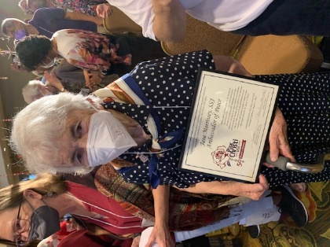
Sr. Jane, Ambassador of Peace (photo by Annette McDermott)
The closing liturgy was celebrated by Bishop John Stowe and Archbishop Wester, again with amazing music and challenging reflections. After Mass the new Ambassadors of Peace (including Sister Jane Morrissey, SSJ) were commissioned—what a cloud of witnesses to encourage and inspire us! After closing remarks the conference officially ended. Some members stayed to walk to the Pentagon in a Prayer Witness.

Before the official conference, state and regional leaders met, as did the Youth Caucus. All who had arrived early were invited to a special showing of The Berrigans: Devout and Dangerous, followed by a panel including Frida Berrigan (Philip’s daughter). Chuckles of remembrance were accompanied by moving emotions and always the challenge to weave peacemaking into every aspect of our lives.
During the conference there was the chance to attend Mass, join in centering Prayer and small group discussions, and visit the numerous exhibitors doing peace and justice work. The tapestry woven from submissions of many members throughout the year was displayed in the chapel, along with PCUSA memorabilia from the past 50 years and memorials for members who are deceased.

The theme of the conference, “Seeing Through the Prism of Justice” reminds us that the light of the Gospel refracts into a rainbow of justice issues when passed through the prism of nonviolence.

-Jeanne is secretary of the Pax Christi MA board of directors.
A Youthful View of PCUSA at 50 in DC
By Clem Kimani
Being a part of Pax Christi USA’s 50th anniversary, I got to see the major theme of the conference in action. the peace and nonviolence of Jesus. Though I grew up in a Christian household, this seemed to me the big difference between Catholicism and most other Christian traditions. That is, standing with all the victims who suffer in the world, and taking concrete actions to help them, including protests, rather than just praying about the situation.
“Blessed are the peacemakers, for they are the children of God,” one speaker said in a conversation that really made me realize that we as children of God need to create peace through all the bad things that may be happening in our lives and in the world.

I learned so much about peace and nonviolence in such a short time, I left the conference with great positivity and the mind of a determined peacemaker!
-Clem is a sophomore at Elms College in Chicopee (see page 2).
Springfield Diocese Endorses Back from the Brink
By Mike Moran
At an August 6 Hiroshima Day commemoration co-sponsored by Pax Christi and Greater Springfield Campaign Nonviolence in Springfield, Bishop William D. Byrne announced to the 50 or so attendees: "The Diocese of Springfield heartily endorses Back from the Brink!"
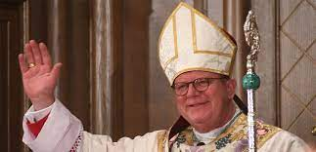
Bishop Byrne (diospringfield.org)
This was just after four interfaith panelists had read Thomas Merton's 1962 prose poem "Original Child Bomb," Dr. Ira Helfand had made a powerful case for nuclear disarmament through the BftB five-point legislative agenda, which would culminate in the United States signing the Treaty on the Prohibition of Nuclear Weapons, and just before the Bishop went on to quote Pope Francis's strong words in Hiroshima against even the possession of nuclear weapons and closed the event with the Prayer of St. Francis.
The Springfield Diocese is only the second US Catholic diocese to endorse BftB, after the Diocese of Little Rock in Arkansas. Pax Christi Western MA members are offering thanks, support, and assistance to Bishop Byrne in sharing this good news with parishioners throughout the Springfield diocese.
-Mike is editor of this newsletter.
___________________________
Atomic Bombings Remembrance
By Pat Ferrone
Parishioners at St. Susanna Parish in Dedham read this reflection on August 9 in their Peace Chapel. A recording can be viewed here:
https://www.youtube.com/watch?v=VMl07JZ7cBU
On August 6 and 9, people of faith and conscience have come together for 77 years to mourn the anniversaries of the Hiroshima and Nagasaki atomic bombings. Today at St. Susanna Parish, we gather to remember and repent the deaths of Japanese citizens in the bombings and firestorms that instantly annihilated thousands and created a hell on earth. As citizens of the US and as Christians, we ask forgiveness. We vow, with the grace and mercy of God, to use our time on earth to unravel the idolatry of nuclear weapons and the mystique of redemptive violence. We pray to be prophets of peace in the nonviolent Way and Spirit of Jesus. Please, now, let us return to the summer of 1945, when the tragic fruit of scientific effort, political expediency, and moral blindness ushered in the atomic era in which we are still enmeshed. We do this in a spirit of compassion for victims and perpetrators, begging mercy.
On July 16, 1945, the first atomic bomb test, code-named “Trinity,” was conducted in an area of desert in New Mexico called Jornada del Muerto - Journey of Death. “We knew the world would not be the same,” recalled J. Robert Oppenheimer, chief scientist of the Manhattan Project, which was responsible for the development of the world’s first nuclear weapon.
As he witnessed the test, Oppenheimer remembered the line from the Hindu Scripture, the
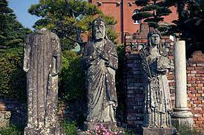
Bombed statues at rebuilt Catholic Cathedral, Nagasaki (wikipedia.org)
Bhagavad Gita, “Now I am become death, the destroyer of worlds.” Three weeks later, the devastation of Hiroshima and Nagasaki foretold the perilous nuclear-armed world which threatens our existence. It is not an exaggeration to suggest that all people, everywhere, live under the threat of apocalyptic destruction.

“Little Boy,” a diabolical creation weighing in at a hefty 9000 pounds, was birthed on August 6 when it exploded over Hiroshima, just as its citizens were beginning their day. The B-29 bomber, named “Enola Gay,” named to honor his mother, was piloted by Colonel Paul Tibbets. She was to carry the “Original Child Bomb,” so named by the Japanese. This “weapon of mass destruction” was more powerful than any ever before seen, and lethal beyond imagining (The Japanese also called them “weapons of the devil”). In a matter of minutes, 70,000 human beings were annihilated from the blast and the enveloping firestorms; the ambient temperature rose to 4000 degrees centigrade; and three-quarters of the city was destroyed. For those writhing in pain and calling for a drink of water in their thirst, there was no help. Those who could, ran to the rivers to escape, but soon “the river became not a stream of flowing water, but a stream of drifting dead bodies.”
[read the rest of this article here]
[print readers, see enclosed insert]
-Pat Ferrone is co-coordinator, with Fr. Rocco Puopolo, s. x., of Pax Christi Massachusetts.
Agape will hold its Francis Day gathering in person Saturday, October 1, 2022, 10am-4pm.
The theme will be a celebration of the community’s 40th anniversary. Arrive early for parking and bring a bagged lunch and vegan potluck offerings. Speakers will include Sr. Claire & Rev. Kato Shoni (Peace Pagoda); Frida Berrigan; John & Carrie Schuchardt (House of Peace); Fr. Emmanuel Charles McCarthy; Nicole Braithwaite-Hunt (Worcester Inter-Tribal Indian Center); Steve & Nancy James; Fr. John P. Sullivan (La Salette Shrine/NH); Sr. Melinda Pellerin (National Black Sisters Conference); Michael Boover (Mustard Seed CW); Linda Reimer (Sirius Community); Larry Buell (University of the Wild); others.
Learn more on Agape’s web site (https://agapecommunity.org/) or: www.facebook.com/agapecommunityma

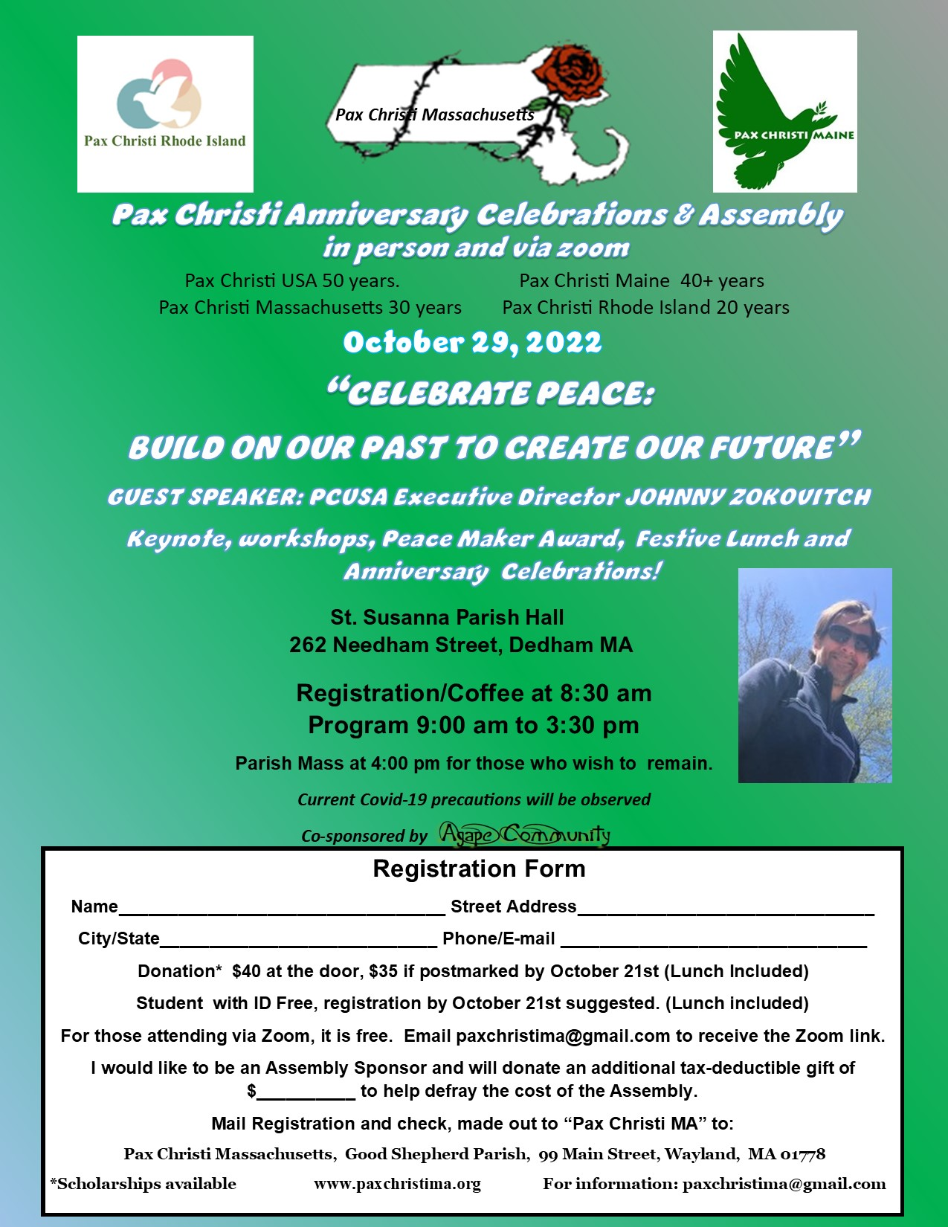

Of Moonbeams, Boots, Mosquitos
Rev. John McDonagh, pastor of Sts. Patrick & Raphael Parish in Williamstown, celebrated the annual Mass co-sponsored by Pax Christi Western MA in honor of Blessed Franz and Franziska Jagerstatter and delivered this homily.
“How do you catch a moonbeam with your hand?” In the musical The Sound of Music, Maria’s friends muse what to make of “(Sr.) Maria.” They try to sort out who Maria is; they seek to understand Maria. Who is she? They sit with their question which they formulate as: “How do you catch a moonbeam with your hand?” A moonbeam is everywhere. And so is Maria.

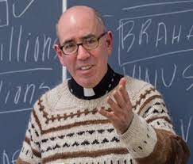
Fr. John McDonagh
(williamstowncatholics.org)
And so is Sister Jane Morrissey, SSJ. She, too, is “a moonbeam” …reflecting the light of Christ in many places: as academician at Elms College, as a writer, as a co-founder of organizations as varied as Homework House and the Gray House, as President of the Sisters of St. Joseph. In 2017, she was appointed Grand Marshall of the Holyoke St. Patrick’s Day Parade. Sr. Jane’s presence animates the residents of the North End of Springfield, where she has lived for years. Her presence comforts people grieving from violence.

I recall Sr. Jane and Mike Moran participating in a Springfield “Walk to End Gun Violence.” Stops along the way included: visiting with and listening to a mother who had lost her son to gun violence and stopping to listen only blocks away to another mother who felt she had no choice but to turn her son into the police for shooting.
A Springfield College student on the walk felt overwhelmed to witness such suffering. In a reflection on Palm Sunday, he shared with his Catholic peers at the College the mothers’ experience. The student concluded that the passion, death, and resurrection of Jesus lives on in our day. The resurrection lives when people move toward forgiving, letting go and taking steps for peace. The mothers, the walkers and the student were offering peace.
The National Council of Pax Christi USA salutes Sister Jane Morrissey, SSJ this weekend as an Ambassador of Peace. Sister Jane has been “a moonbeam,” a light of Christ, and a source of encouragement to so many promoting peace.

Jesus tells us in the Gospel: “Do not be afraid, for the Father gives you the kingdom.” Jesus teaches us to pray in the Our Father, “your kingdom come,” as in “May your kingdom come where we are…” God’s kingdom is not a place one enters only in heaven. The reign of God is a dynamic reality that asks of us to take initiative where we are to bring peace.
As followers of Jesus, through prayer, we subvert the present unjust order by recognizing God is the only king. There is no other God. The Lord’s Prayer radically relativizes every human scheme and utopia. Being treated as anarchists and subverters of conventional social and political order does not surprise ardent Christians.
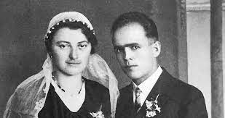
Newlyweds, 1936
(denvercatholic.org)
Blessed Franz Jagerstatter, born in Austria in 1907, became known as an ordinary and humble Catholic. In 1936, Franz and Franziska, his bride, honeymooned in Rome. Returning to Austria, he began working as the parish sexton, receiving the Eucharist daily. At the time, Austria began to follow the tide of Nazism. Franz responded by rooting himself in his Catholic faith and placing complete trust in God. By now, Franz, as a husband and father of three daughters, thought deeply about obedience to legitimate authority and obedience to God.
When called up in February 1943 to fight for Hitler, Franz refused, offering instead to carry out nonviolent services. The Nazis denied his request. He knew the likely consequences. And Franziska knew. Yet, with her support, and aware of the sacrifices his decision might impose on her, Franz maintained his pacifist view. Franz died at peace following God’s will. He was beheaded on August 9, leaving Franziska to raise their family alone. Both spouses sacrificed for peace.

Pax Christi and its members sometimes seem like a pesky mosquito at a summer evening barbecue. Pax Christi attempts to get our attention: violence does not have to be the default response. War does not have to be a way to resolve conflict. We don’t have to live in fear.

All that disturbs us challenges us. We thank God for Pax Christi’s voice. We thank God for the witness of Franz Jagerstatter. We thank God for Sr. Jane Morrissey, SSJ, a true Ambassador of Peace. May we have the courage to hear their voice. Doing so, we will put on the mind and heart of Christ. Let us ask the Lord, how we, too, can be ambassadors of peace?
IntergenerationalSpring Retreat
By Jeanne Allen
Forty-one peacemakers joined Sr. Jane Morrissey, SSJ, and Fr. Brian Ashmankas for a jam-packed morning of challenge and hope on April 23, at the Pax Christi—MA retreat “Wisdom Speaks to and from All Ages.” Held via Zoom, the morning opened in reflective prayer and was followed by a series of short videos created by high school and college students on their concerns for the future. Topics as varied as depression related to Covid-19, human trafficking, child labor, nuclear war, climate change, elder abuse, refugees, racism, and the death penalty were addressed, often specifically in the context of Catholic Social Teaching.
Many underlying themes emerged, including economic injustice and race, showing the intersectionality of many of the world’s challenges.
Next, Sr. Jane and Fr. Brian responded and reacted to the videos, and participants also

From a student death penalty video
responded in the “chat.” We broke into small groups and then returned to recap our discussions. Again, we recognized many themes: the courage the young people showed in sharing their fears, the importance of listening and “standing with,” the centrality of community—from it comes wisdom, courage, hope, and a chance to delve into the systemic side of issues. Youth have a wisdom and clarity that can become lost as we age. They inspire us and give us hope. The importance of prayer in sustaining us and guiding us was also evident.
Rose Morrissey recalled that Sue Malone was often out at the Westborough rotary with signs addressing various peace issues, and Hiroshima/Nagasaki remembrance was especially close to her heart. Rose wanted to honor Sue for being on the rotary alone, so she called a friend who accompanied her. Community gives us the opportunity for small acts of courage and commitment.

But more than small acts, public or private, is needed. Working locally can have a big impact, especially in areas like housing and helping refugee families settle into new lives. We can join a group such as Catholic Mobilizing Network in urging clemency for inmates on death row. We can join others in praying for the people of Ukraine. We can work with Massachusetts Catholics for Indigenous Rights.

The morning ended with a video of a choir performing a work composed in solidarity with and praying for peace in Ukraine.
Pax Christi MA Board
of Directors 2021-2022
Co-Coordinator: Co-Coordinator:
Pat Ferrone Fr. Rocco Puopolo, s.x
238 Harris Avenue 101 Summer Street
Needham Holliston
MA 02492 MA 01746
781-752-9722 202-997-8049
patferrone@gmail.org (email page 12)
Treasurer: Secretary:
Nancy Carapezza Jeanne Allen
13 Red Barn Road 10 Sutton Place
Wayland, MA 01778 Easthampton, 01027
508-740-4500 413-270-5880
npez@comcast.net (email page 12)
OTHER BOARD MEMBERS: Sr.Linda
Bessom (Somerville); Irene Desharnais
(Jamaica Plain); Phil Harak
(Southampton); Sally Markey
(Springfield); Mike Moran
(Palmer/Newsletter Editor); Rose
Morrissey (Westborough); Sr.Rita Raboin (Somerville)
QUARTERLY BOARD MEETINGS are
held virtually at 10:00 AM and are open
to all PCMA members. The next one
is scheduled to be on December 10, 2022.

Local Groups

Berkshire P.C.
Carolyn Zablotny
P.O. Box 14
Mill River, MA 01244
berkshire.pax.christi@gmail.com
Contact for meeting info
Beverly P.C.
Karen Watkins
(978) 524-0029
bluelight-1@live.com
Sr. Linda Bessom, SNDdeN
(857) 236-1370
linda.bessom@sndden.org
Mtgs 2nd Tuesday, 7:00 pm
St. Mary’s Convent
Boston (Citywide) P.C.
Sr. Rita Raboin, SDNdeN
Paulist Center, 5 Park St
Boston, MA
rita.raboin@yahoo.com.br
Contact for meeting info
Cape Cod P.C.
Edouard & Francoise Rocher
77 Old Post Road
Centerville, MA 02632
(508) 771-6737
paxchristi-cc@comcast.net
Our Lady of Victory
Centerville, MA 02632
Contact for meeting info
Central Mass P.C./Our Lady of Guadalupe P.C. (MCI Shirley prison chapter)
Roger & Charlotte Stanley
55 Pleasant Street
Berlin, MA 01503-1610
cstanley041258@verizon.net
St. Rose of Lima Parish
Northborough, MA 01532
Contact for meeting info
Fatima Shrine P.C.
Fr. Rocco Puopolo, s.x.
101 Summer Street
Holliston, MA 01746
(202) 997-8049
rndpsx@hotmail.com
Mtgs 2nd Friday, 4:00 PM
Upper Room
Holy Cross College P.C.
1 College St, Box 16-A
Worcester, MA 01610
Marty Kelly
(508) 793-2617
mkelly@holycross.edu
Meetings and activities geared to college calendar
Holy Cross Parish P.C.
221 Plumtree Road
Springfield, MA 01118
Marilyn Paul-Lewis
(413) 739-3278
parishsocialministry@gmail.com
Contact for meeting info
Metro West P.C.
Jan Leary
peacejpl@comcast.net
Mtgs 3rd Wednesday, 1:00 PM
Natick Public Library
National Shrine of Our Lady of La Salette P.C.
Sheila Matthews
199 Maple Street
Somerset, MA 02726
(508) 674-8220
sheilmatthews@aol.com
Mtgs 3rd Tuesday, 7:00 PM
Chapel of Reconciliation
Rhode Island P.C.
Margo Murphy
(401) 861-6988
margomurph@aol.com
Madeline Labriola
(845) 691-8015
mlabriola@mac.com
St. Peter’s Church
Lower level
350 Fair Street
Warwick, RI 02888
Mtgs last Sunday, 6:00 PM
St. John’s Prep P.C.
St, John's Preparatory School
72 Spring Street
Danvers, MA 01923
Bill Mackinson
(978) 774-1057
wmackinson@stjohnsprep.org
Prayer for Peace, Tuesday mornings, 7:45-8:00 AM
St. Susanna Parish P.C.
Pat Ferrone
262 Needham Street
Dedham, MA 02026
(781) 752-9722
parferrone@gmail.com
Contact for meeting info
Western Mass P.C.
Jeanne Allen
10 Sutton Place
Easthampton, MA 01027
(413) 270-5880
jeanne.allen@hhcinc.org
Mtgs 2nd Friday, 7:00 pm
Elms College, Chicopee
(NOTE: Meetings of some groups may be virtual due to Covid-19)

If you belong to a Pax Christi group that is not listed above, please let us know so we can add it to our list. If any information above is incorrect, or if you would like to be added to a list of Pax Christi “friends” and receive current messages from the Board, please send changes or additions to Mike Moran: moran3@comcast.net (135 Shearer Street, Palmer, MA 01069)
Pax Christi Massachusetts
Good Shepherd Parish
99 Main Street, Wayland, MA 01778
paxchristima@gmail.com
www.paxchristima.org

